Brendan Yeong

Student ID: 005025797

Course: MSCS532

Project Deliverable 2

Dynamic Vehicle Registration Management System with Efficient Expiration Tracking and License Plate Search

Deliverable 2:

1. Partial Implementation of Data Structures:

Dictionary for Vehicle registration to store all the main data.

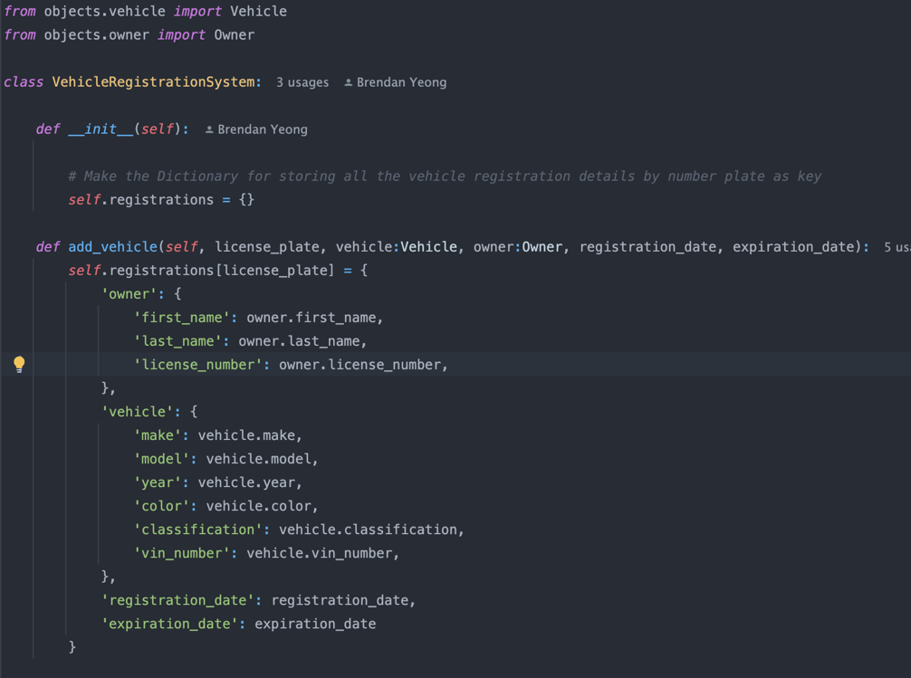

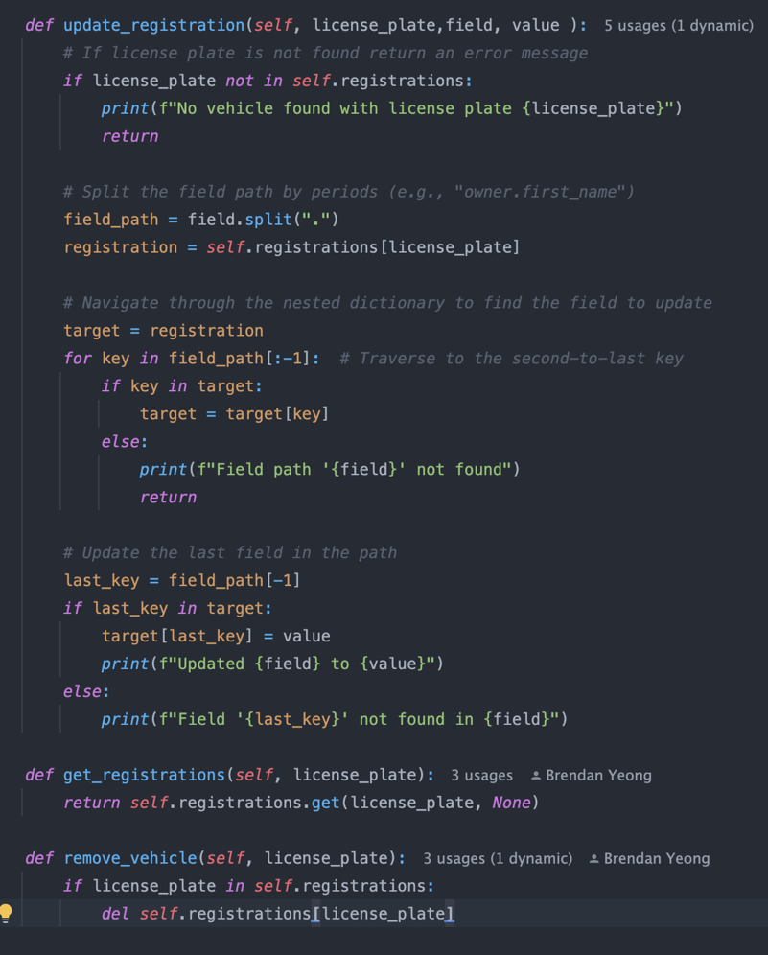

Priority queue for the Expiration dates tracker to identify the next registration that will expire.

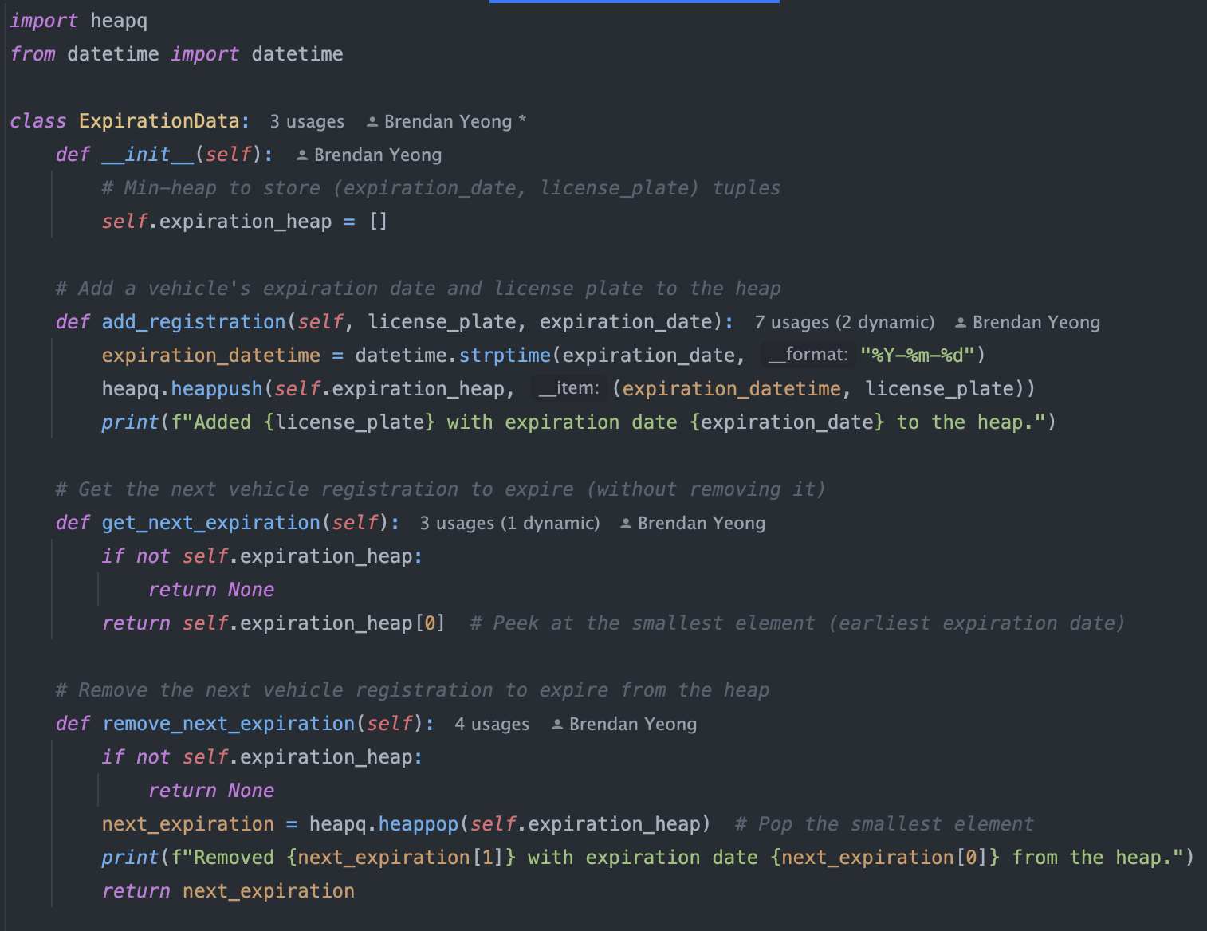

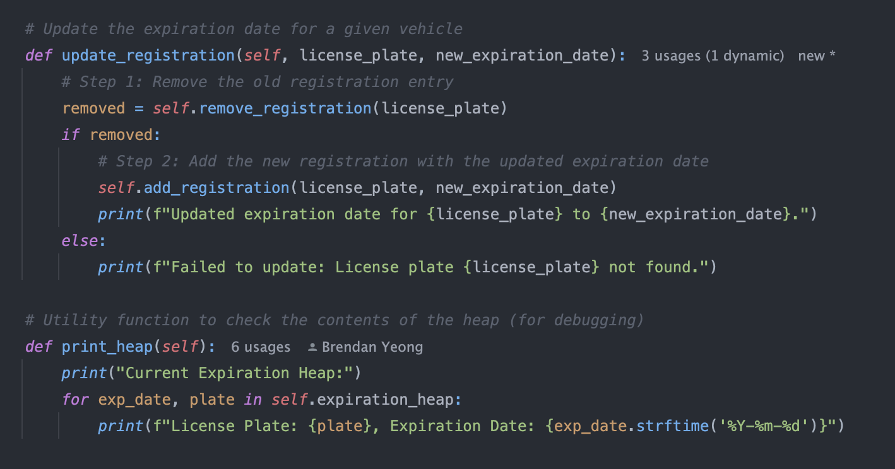

AVL Tree for the Owner based car registration. It can store the owner and the total number of cars that is owned.

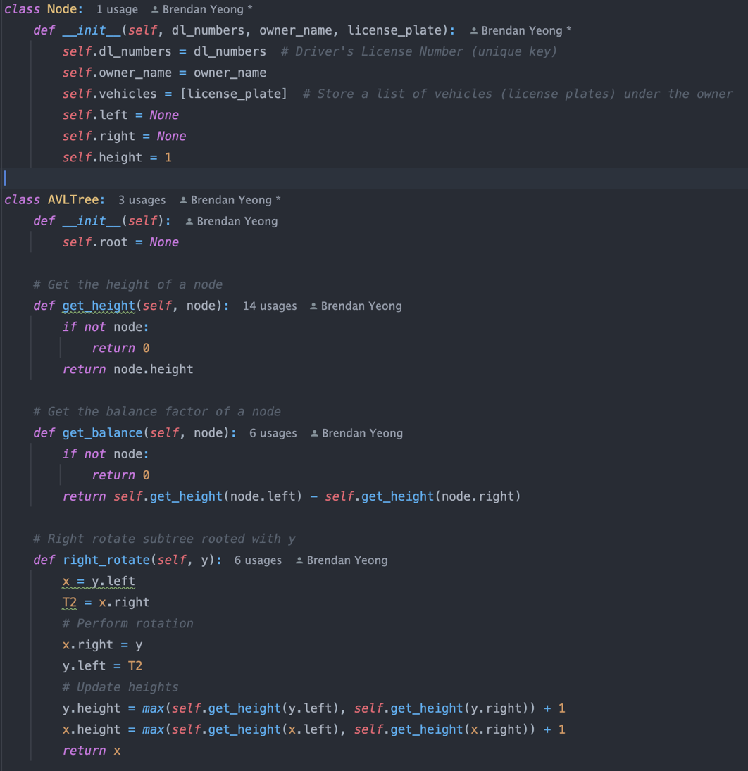

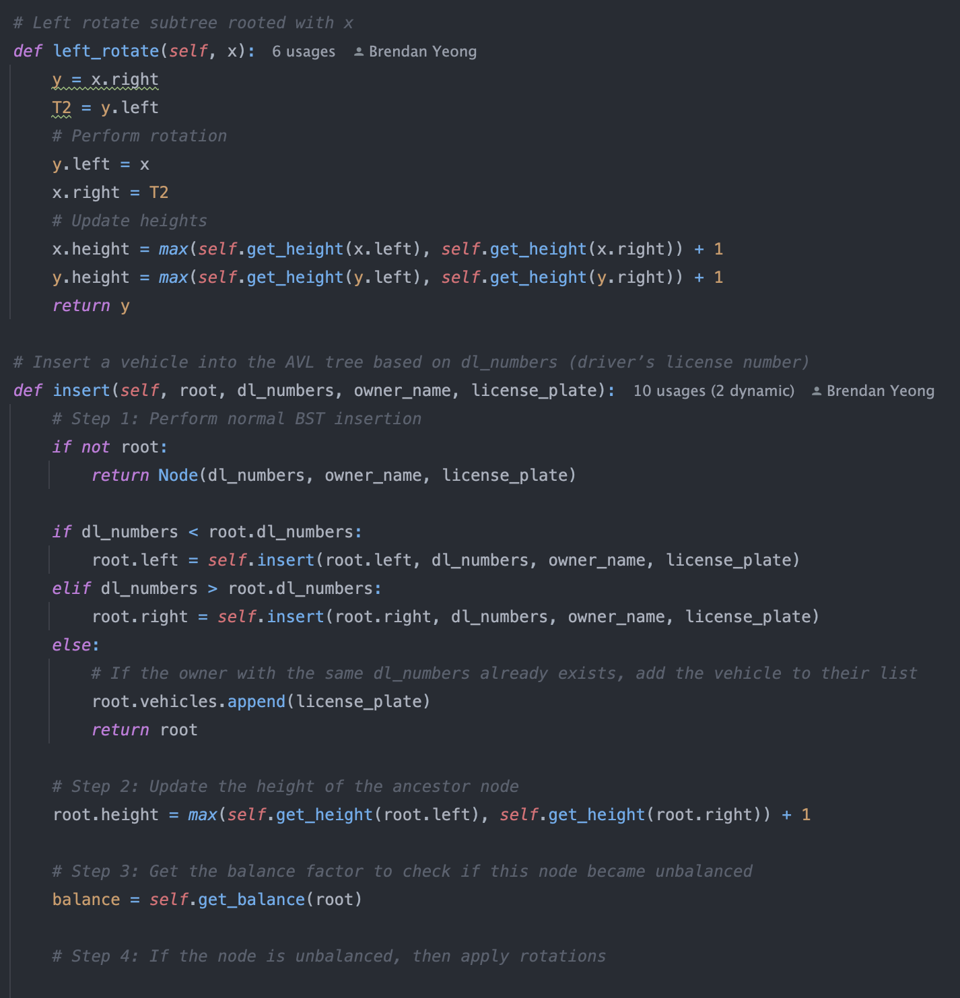

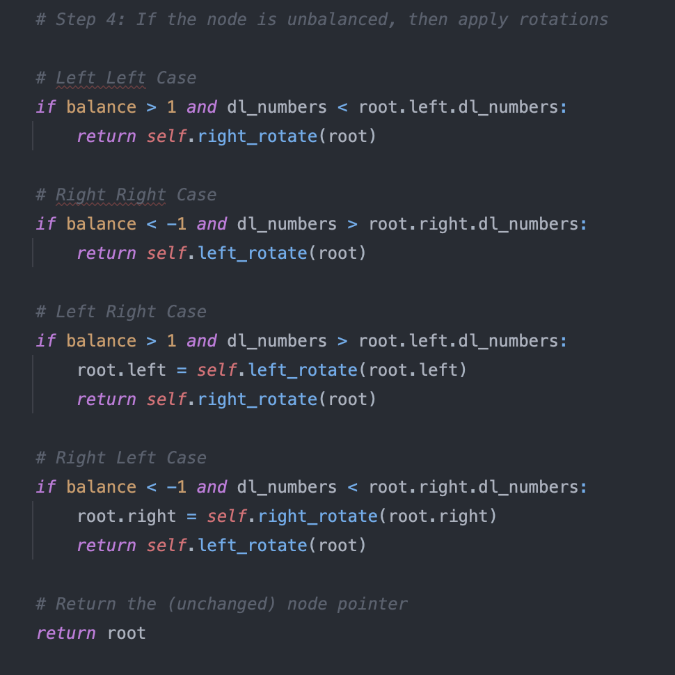

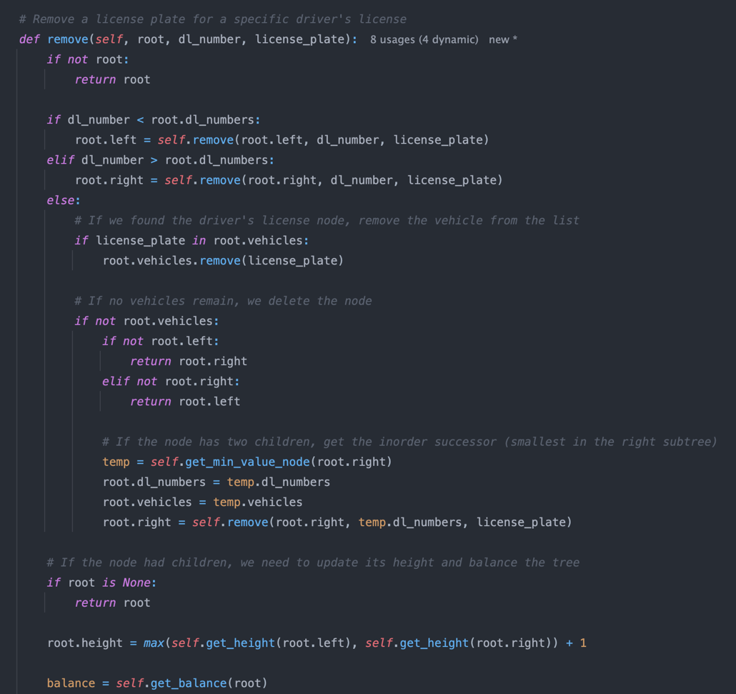

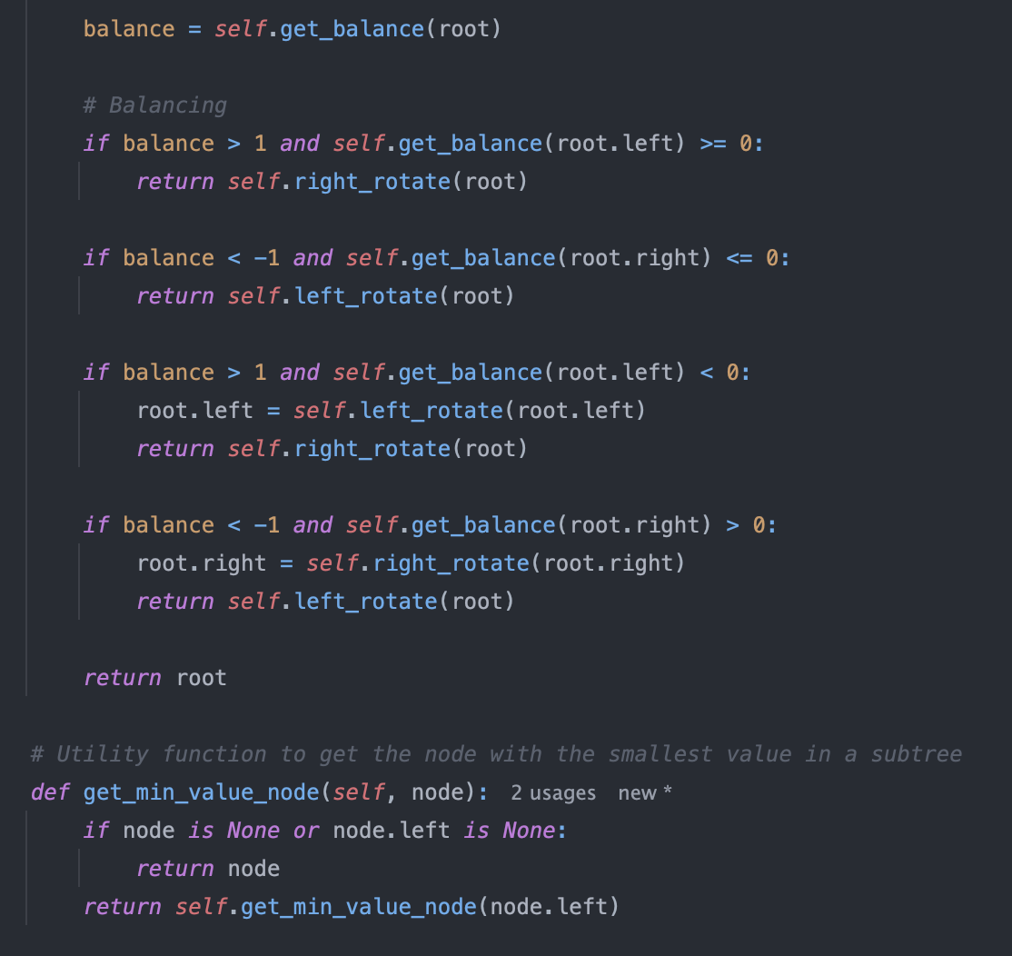

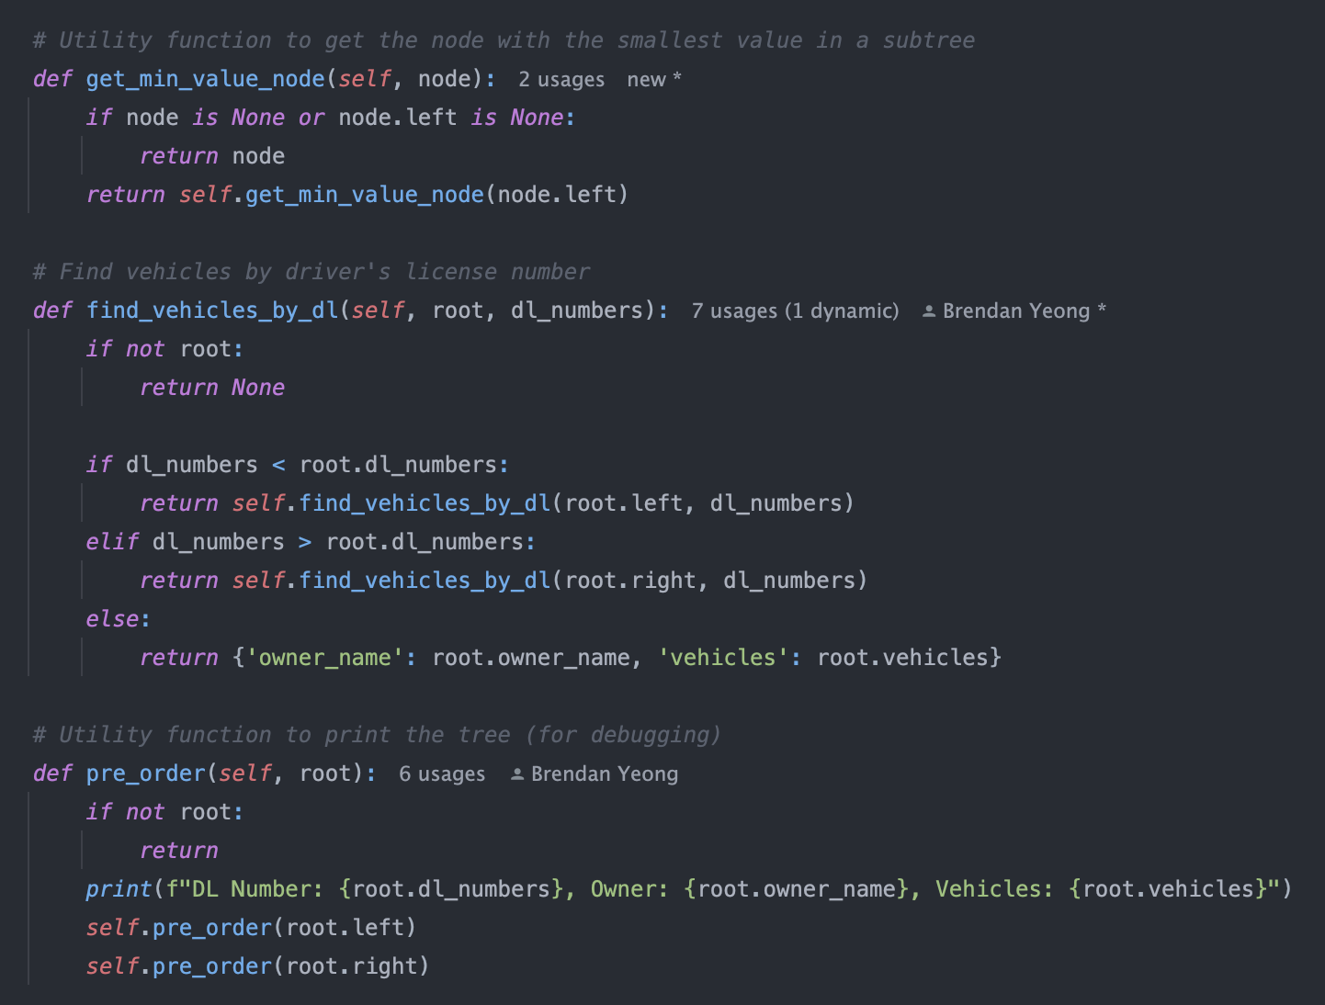

Trie Data Structure for vehicle number plate prefix lookups.

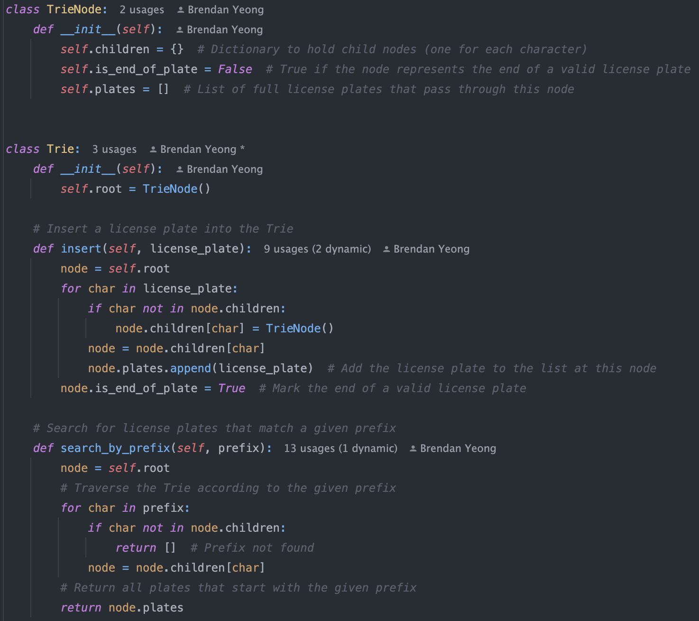

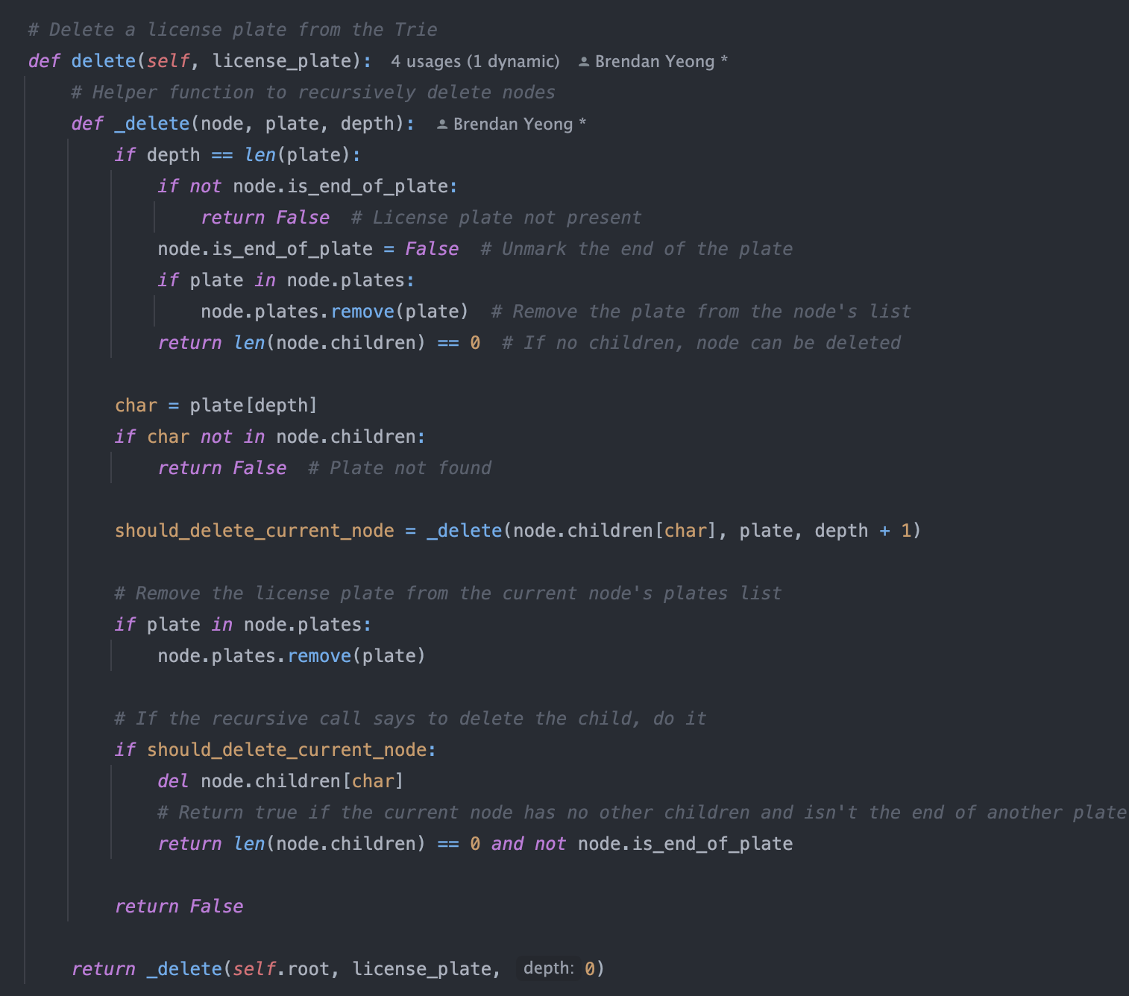

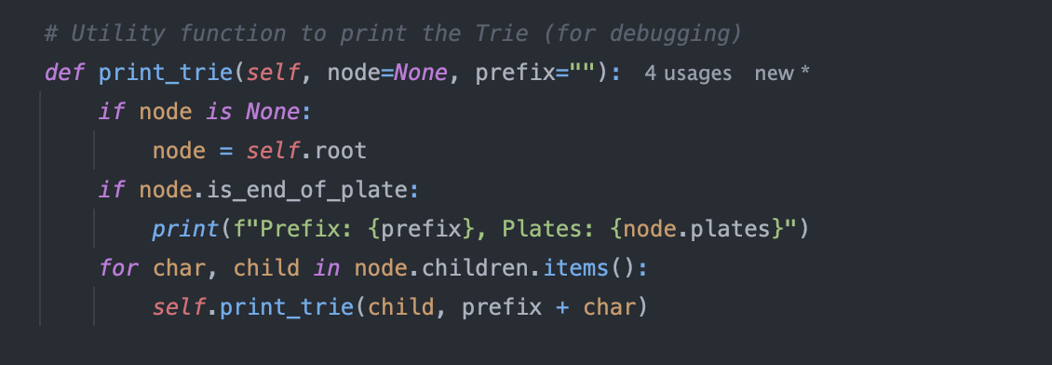

Demonstration of Key Operations:

To demonstration the key operations of each data structure that is partially implemented, I have created some test cases that I can run, and the results will also be attach below it.

Dictionary for Vehicle registration:

Test Case 1: Adding vehicle registrations

* Adds multiple vehicle registrations for different owners and prints the dictionary to verify the entries.
* Tests adding another vehicle registration for the same owner (LMN456 for John Doe).

Test Case 2: Retrieving vehicle registration by license plate

* Retrieves vehicle registration information using the get_vehicle() method. This includes an edge case where the license plate doesn’t exist ("NONEXISTENT").

Test Case 3: Updating specific fields in a vehicle registration

* Tests the update_registration() method to update the owner’s first name, the vehicle’s color, and the expiration date for various license plates.
* Includes an edge case where an invalid field is provided for update ("vehicle.invalid_field"), which should not modify the registration.

Test Case 4: Removing a vehicle registration by license plate

* Tests the remove_vehicle() method to remove an existing registration (ABC123) and verifies the dictionary after removal.
* Includes an edge case where the system tries to remove a non-existent registration ("NONEXISTENT").

Test Case 5: Edge case - Adding a duplicate license plate

* Tests if adding a registration with a duplicate license plate (XYZ789) correctly overwrites or handles the situation based on the system’s logic. The dictionary should reflect the updated registration details.

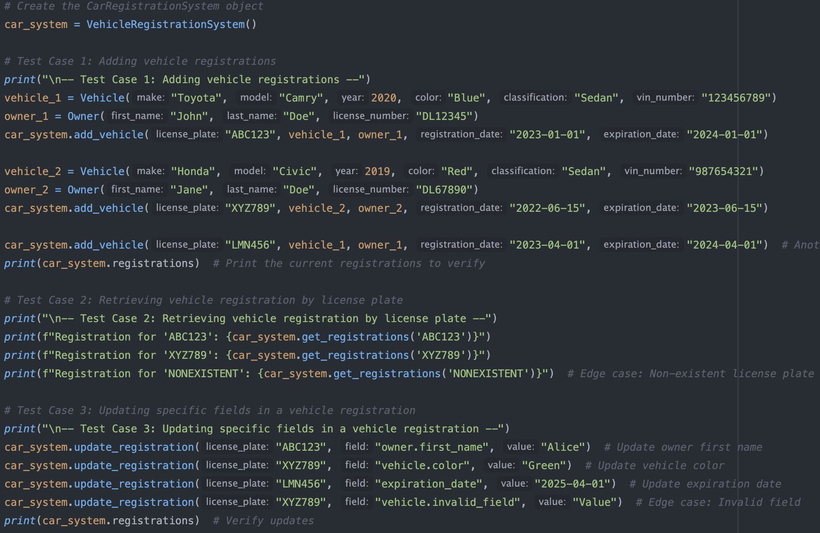

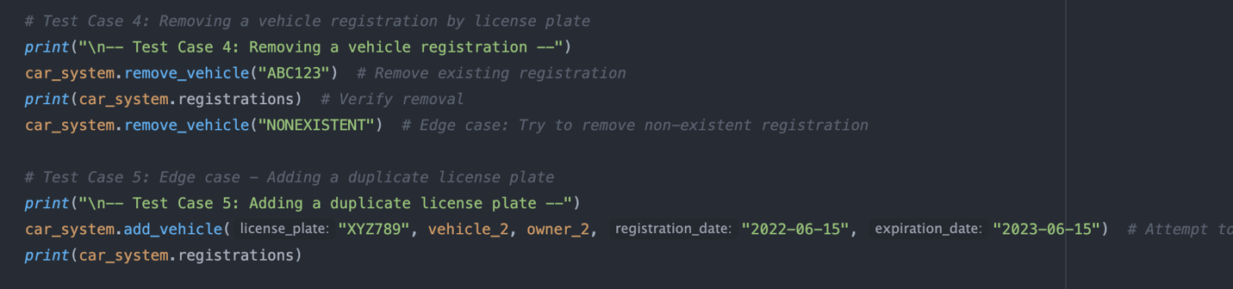

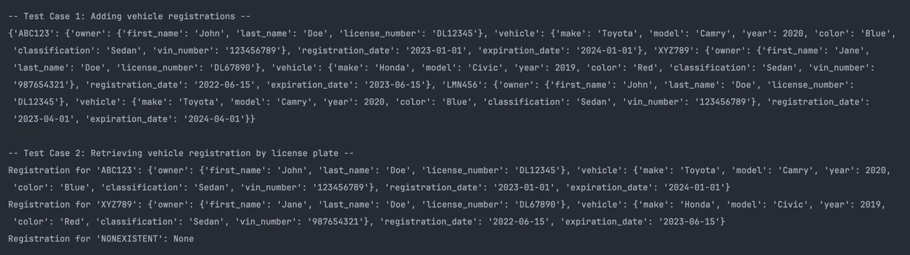

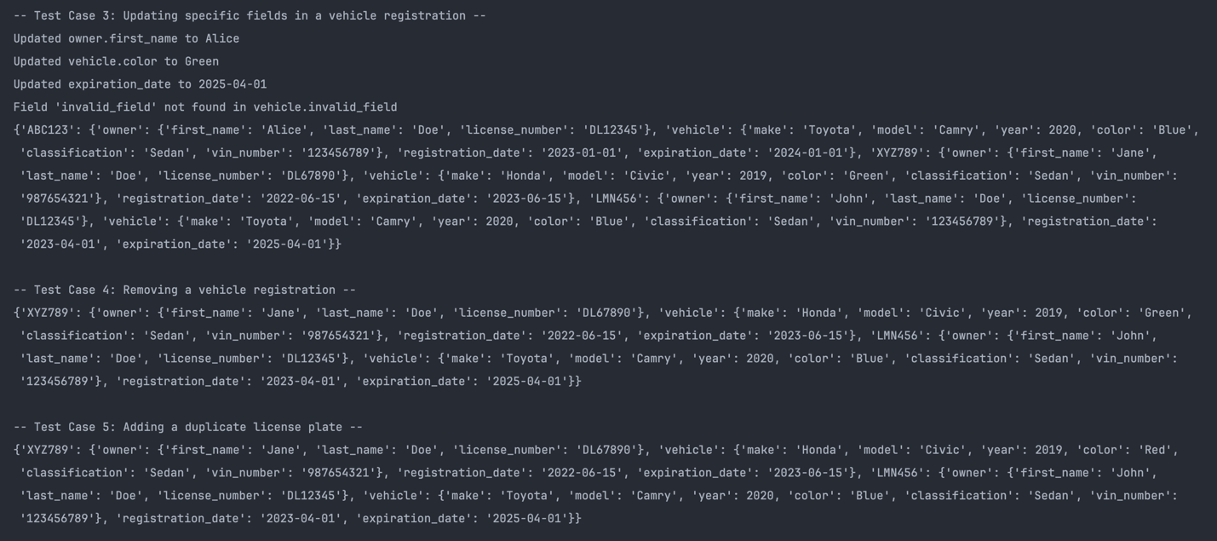

Priority queue for the Expiration dates tracker:

1. Test Case 1: Adding vehicle registrations

* This test adds several vehicle registrations with different expiration dates to the priority queue. The print_heap() function is used to display the current state of the heap to verify that the heap structure is maintained correctly.

1. Test Case 2: Get the next registration to expire

* This test checks whether the heap correctly returns the registration with the soonest expiration date using the get_next_expiration() method. The expected behavior is that the earliest expiration date should be at the root of the heap.

1. Test Case 3: Remove the next registration to expire

* This test removes the next vehicle registration to expire using remove_next_expiration(), and then prints the heap to ensure the heap is still properly ordered and balanced.

1. Test Case 4: Remove a specific registration (valid case)

* This test removes a specific registration from the heap using the remove_registration() method. It tests whether the heap can handle removal by license plate and still maintain its structure after removal.

1. Test Case 5: Try to remove a non-existent registration

* This tests the behavior when attempting to remove a license plate that does not exist in the heap. The heap should remain unchanged, and an appropriate message should be printed.

1. Test Case 6: Edge Case - Removing from an empty heap

* This test simulates updating the expiration date for an existing registration where it uses the update_registration(). The heap should have the updated dates, and gets printed to check the values.

1. Test Case 7: Edge Case - Removing from an empty heap

* This test simulates removing all elements from the heap, eventually leaving it empty. It then verifies the behavior when trying to remove from an empty heap and when calling get_next_expiration() on an empty heap, which should return None.

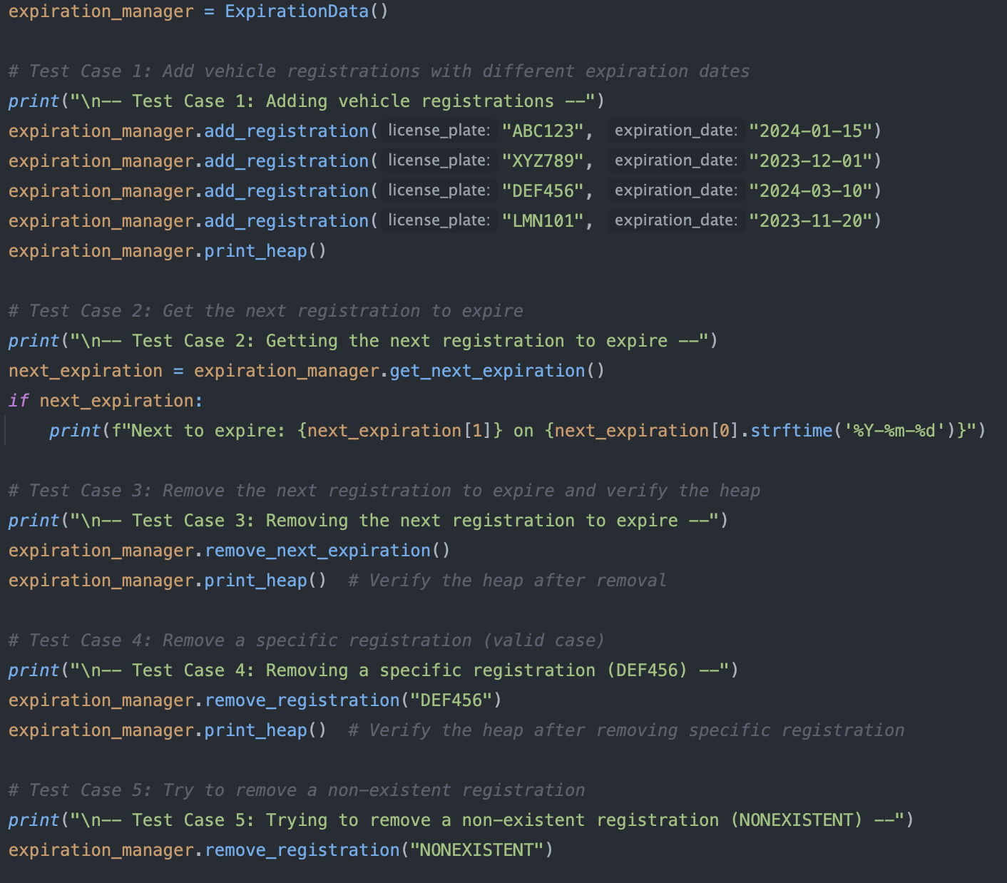

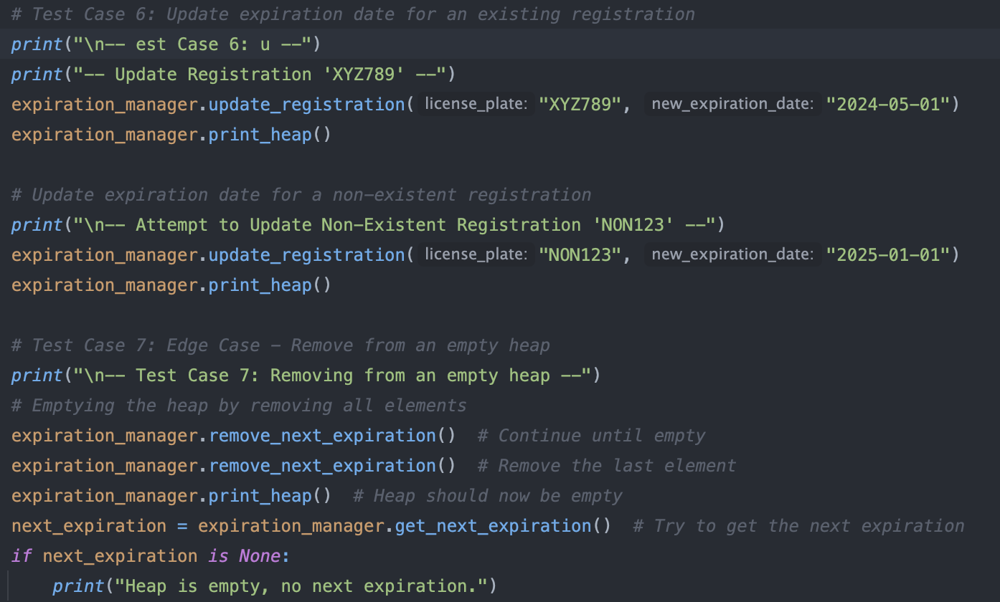

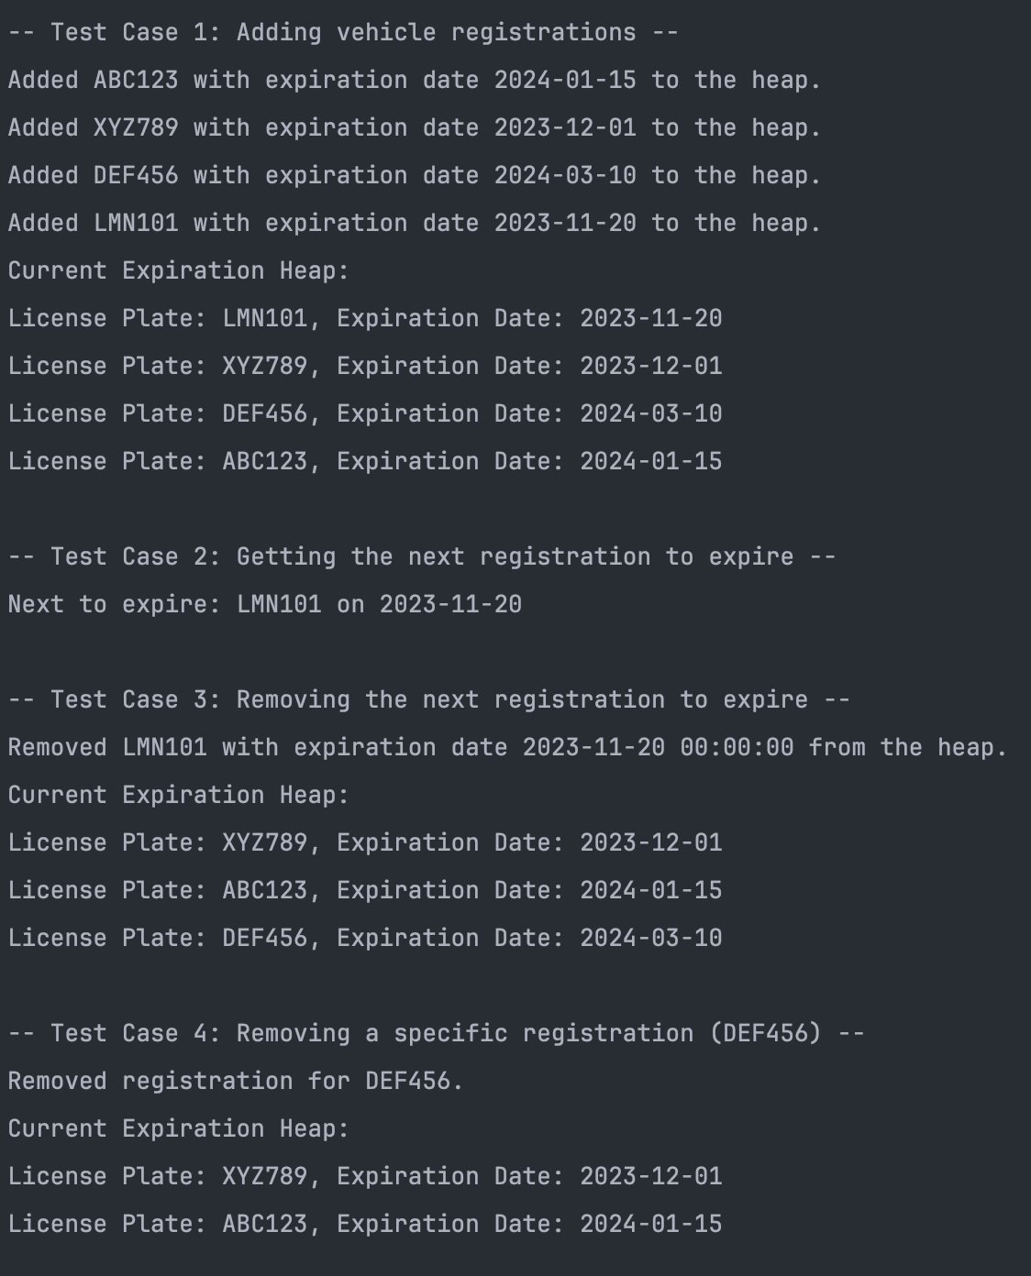

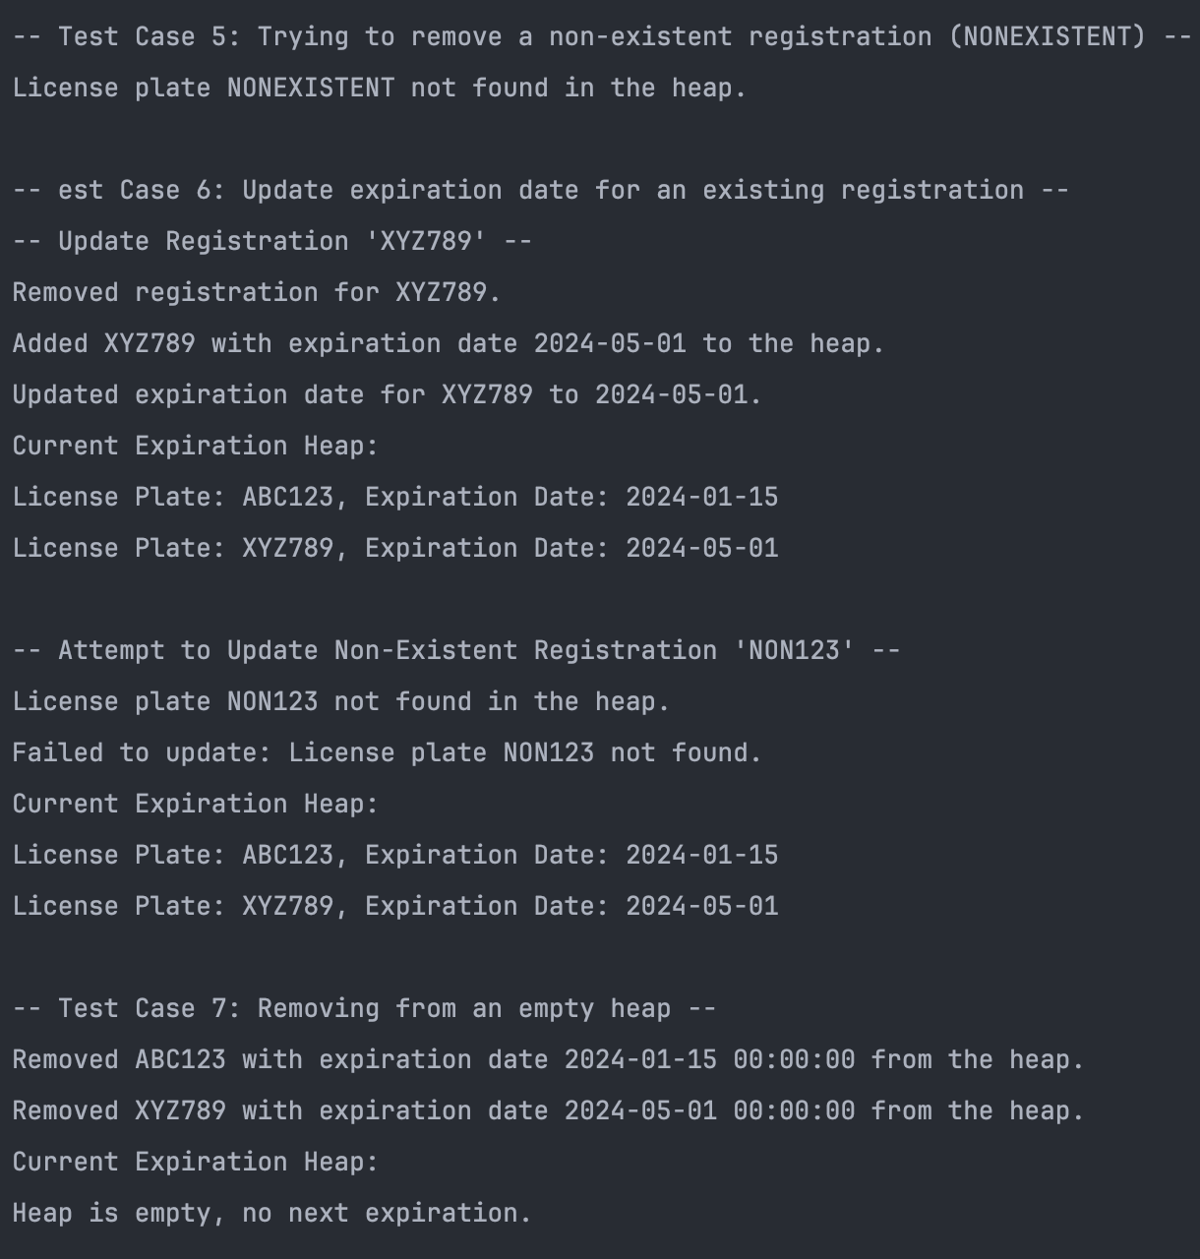

AVL Tree for the Owner based car registration:

1. Test Case 1: Insert vehicles for different owners

* This tests the insertion of vehicles into the AVL tree for different owners, each having a unique driver's license number (dl_numbers). The pre_order() function prints the structure of the AVL tree after insertion to ensure it's balanced.

1. Test Case 2: Insert multiple vehicles for the same owner (with repeated dl_numbers)

* This test checks the ability of the AVL tree to handle multiple vehicles for the same owner. The insertion function should append the new license plate to the existing node for the same dl_numbers.

1. Test Case 3: Search for vehicles by driver's license number (dl_numbers)

* This tests the search functionality by retrieving the list of vehicles for a specific driver's license number. The find_vehicles_by_dl() method is used for this purpose.

1. Test Case 4: Edge case - Search for a non-existent driver's license number

* This tests the behavior of the AVL tree when trying to search for a driver's license number that doesn't exist in the tree. The search function should return None or an appropriate message.

1. Test Case 5: Removing a license plate

* This tests removes a license plate according to the driver’s license number.

1. Test Case 6: Insert into an empty AVL tree (Edge case)

* This tests the insertion function when starting with an empty AVL tree. The tree should correctly handle the insertion and maintain its structure.

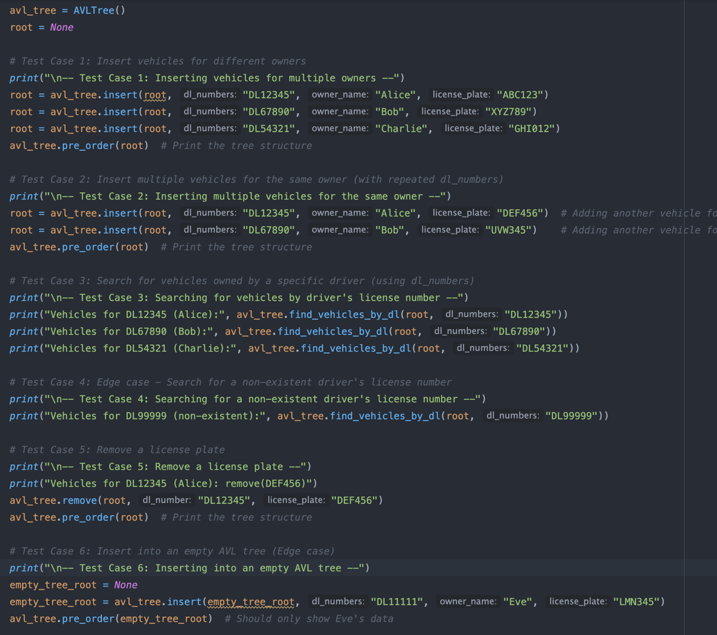

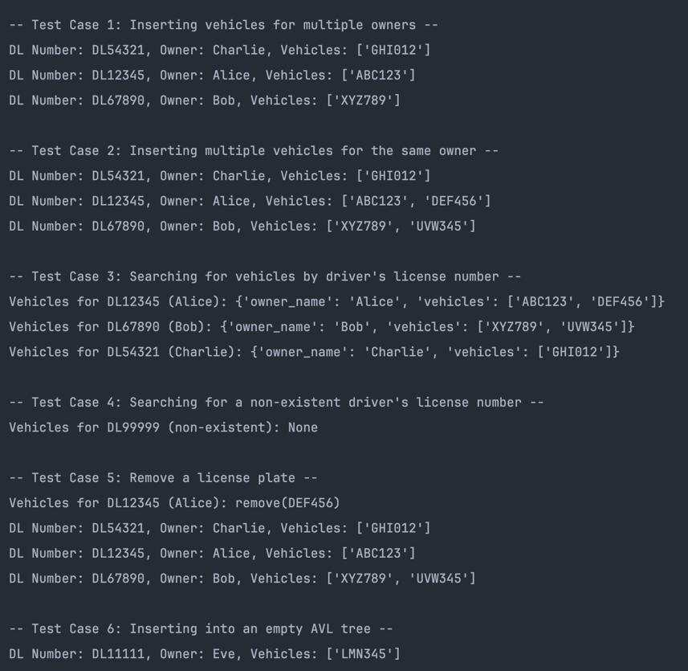

Trie Data Structure for vehicle number plate prefix lookups:

1. Test Case 1: Insert license plates into the Trie

* Inserts several license plates with different prefixes into the Trie, ensuring the Trie structure is built correctly. This tests the basic insertion functionality.

1. Test Case 2: Search for license plates by prefix

* Tests the search_by_prefix() method with various prefixes, including some that match several license plates (e.g., "ABC" and "XYZ") and some that match only one license plate (e.g., "D").
* An edge case where the prefix doesn't exist in the Trie (e.g., "Z") is also tested.

1. Test Case 3: Edge case - Search for a non-existent prefix

* Tests how the Trie handles searching for a prefix that does not exist (e.g., "NON"). This ensures that the Trie returns an empty list or None for non-existent prefixes.

1. Test Case 4: Deleting specific license plates

* Tests the delete() method by deleting specific license plates and verifying that the remaining plates are still in the Trie. This tests whether the Trie can correctly remove a plate and maintain its structure.

1. Test Case 5: Edge case - Try to delete a license plate that doesn’t exist

* Tests how the Trie handles an attempt to delete a license plate that doesn’t exist (e.g., "NONEXISTENT"). This ensures that the deletion method doesn't break the Trie structure when attempting to remove a non-existent plate.

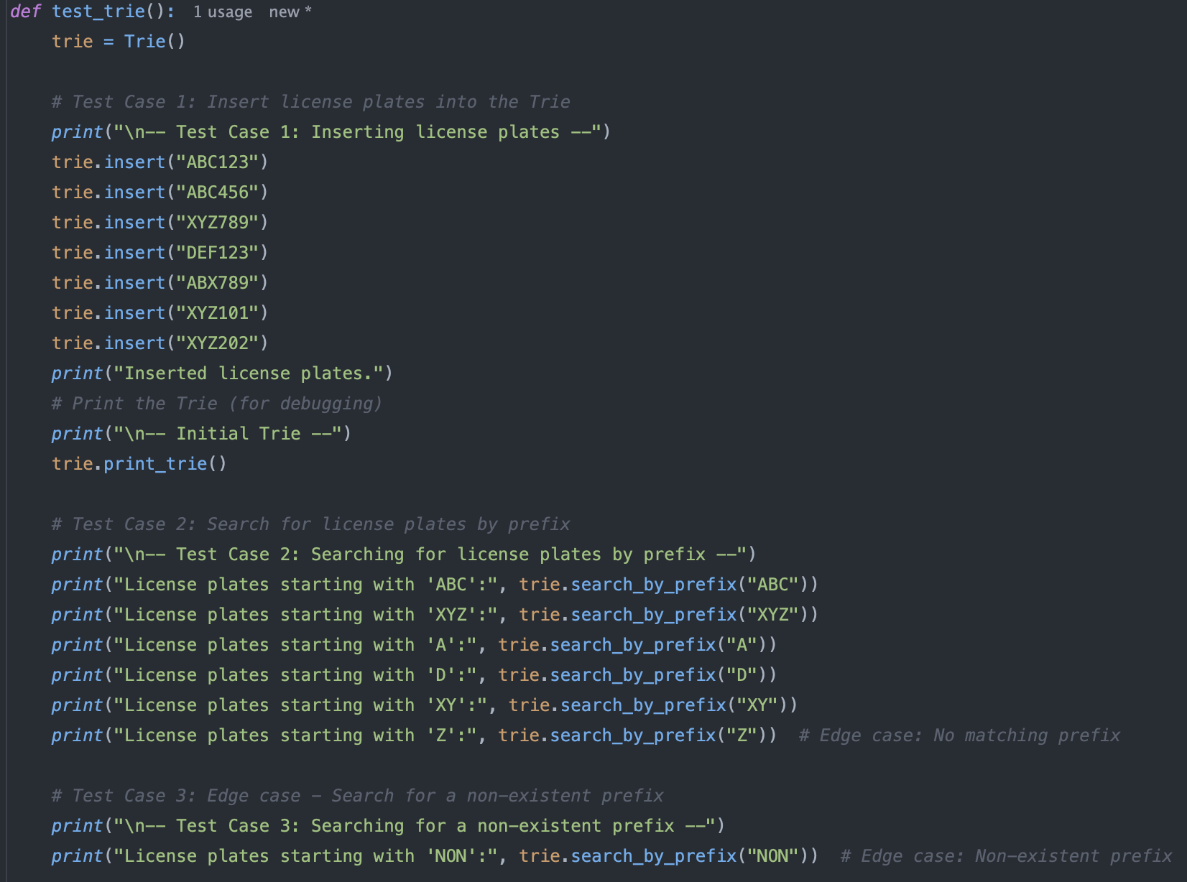

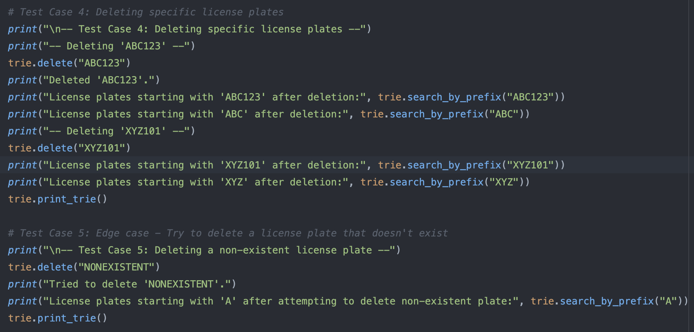

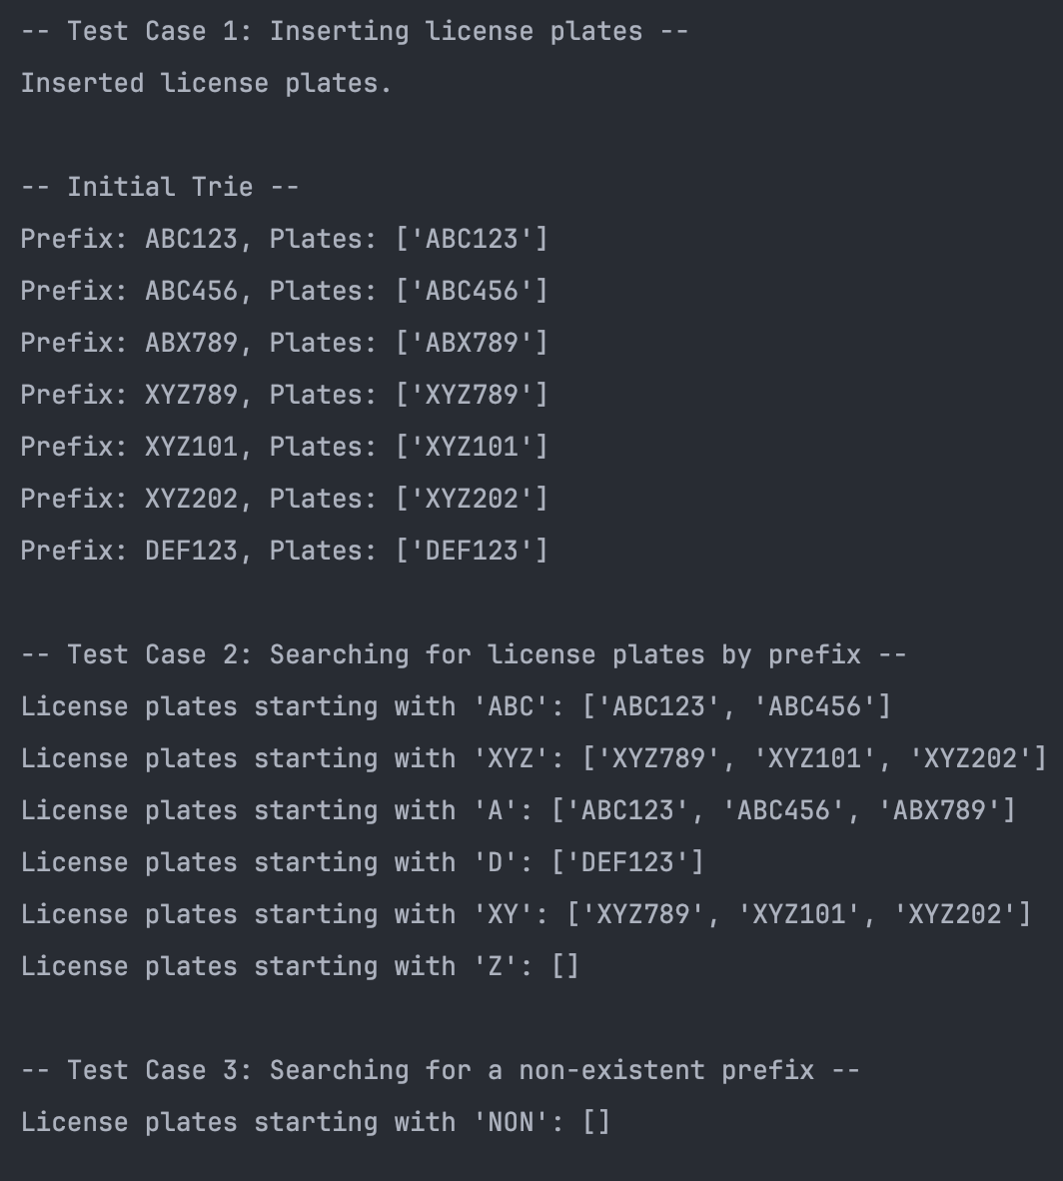

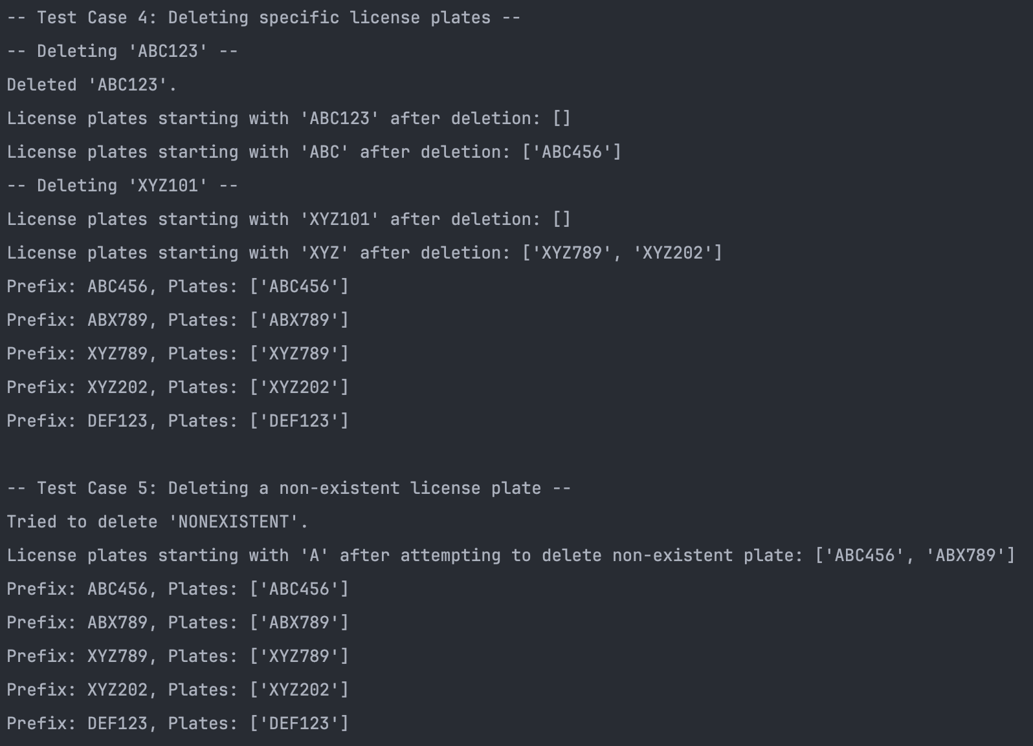

3. Most of my main challenges revolves around seeing how the data structure looks like. To combat these challenges, I simply created utility function such as printing the entire data structures. Fortunately, python 3 has a built-in function for Dictionary structure so I did not have to implement that. But for the priority queue, AVL Tree and Trie data structure I had to implement my own. Here is how they look like:

Priority queue:

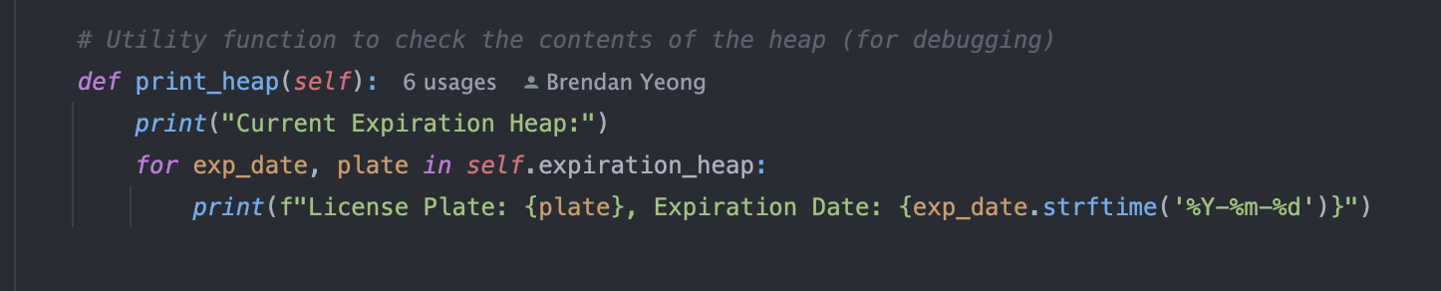  
AVL Tree:

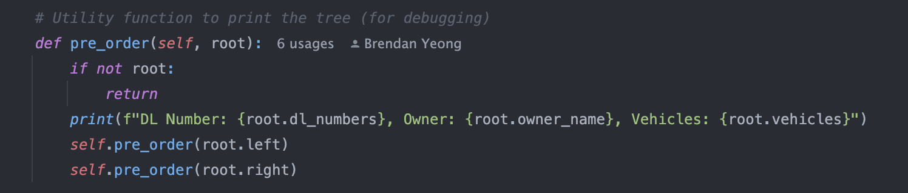  
Trie:

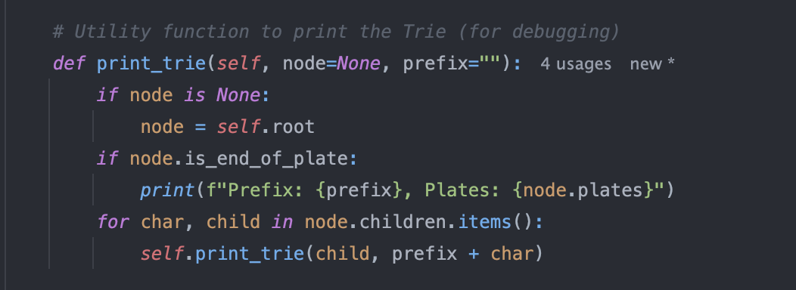

Another Challenge that I faced is that I had to come up with a way to update the priority queue expiration dates. Here are the steps on how I did it.   
To update the expiration date for a vehicle in the Priority Queue (Heap), you need to:

1. Remove the old expiration entry: Since heaps (priority queues) do not allow direct modification of elements, you first need to remove the old expiration entry for the vehicle from the heap.
2. Insert the updated expiration entry: After removing the old entry, insert a new one with the updated expiration date.

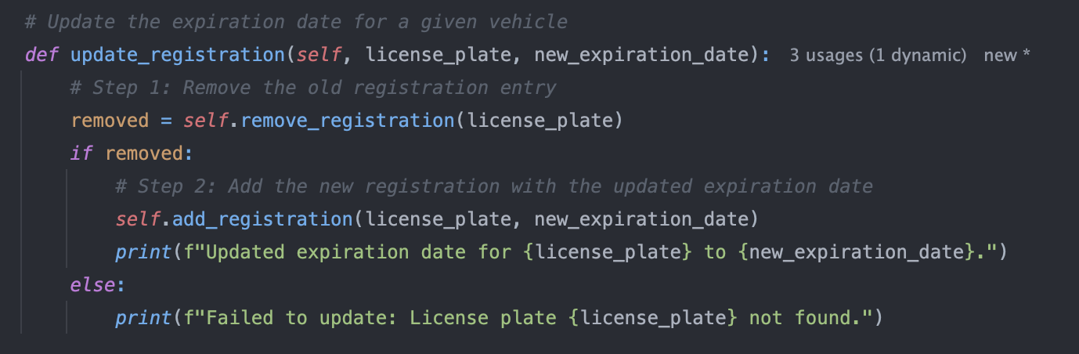

The next steps to complete the full implementation of your application. I simply did some mockup of the system. Here are the current implementations of the choices that will be given.

1. Add vehicle: We need to have an option for the user to add in new registration vehicles and ensuring all the data structures gets the information added into.
2. Search plate by Prefix: Have a way for the user to search plate by prefix and returns a list of plates.
3. Update the expiration date: We need a way to also update the registration expiration dates.
4. Remove vehicle: We need to be able to also remove any vehicle in the data structure.
5. Display all registration: We need to also have an option to display out all the vehicle registration that is stored in the dictionary.
6. Find vehicles by driver’s license: We need an option where we can search a list of vehicles using the owner’s driver’s license number.
7. Exit: To simply kill or stop the simulation of this system.

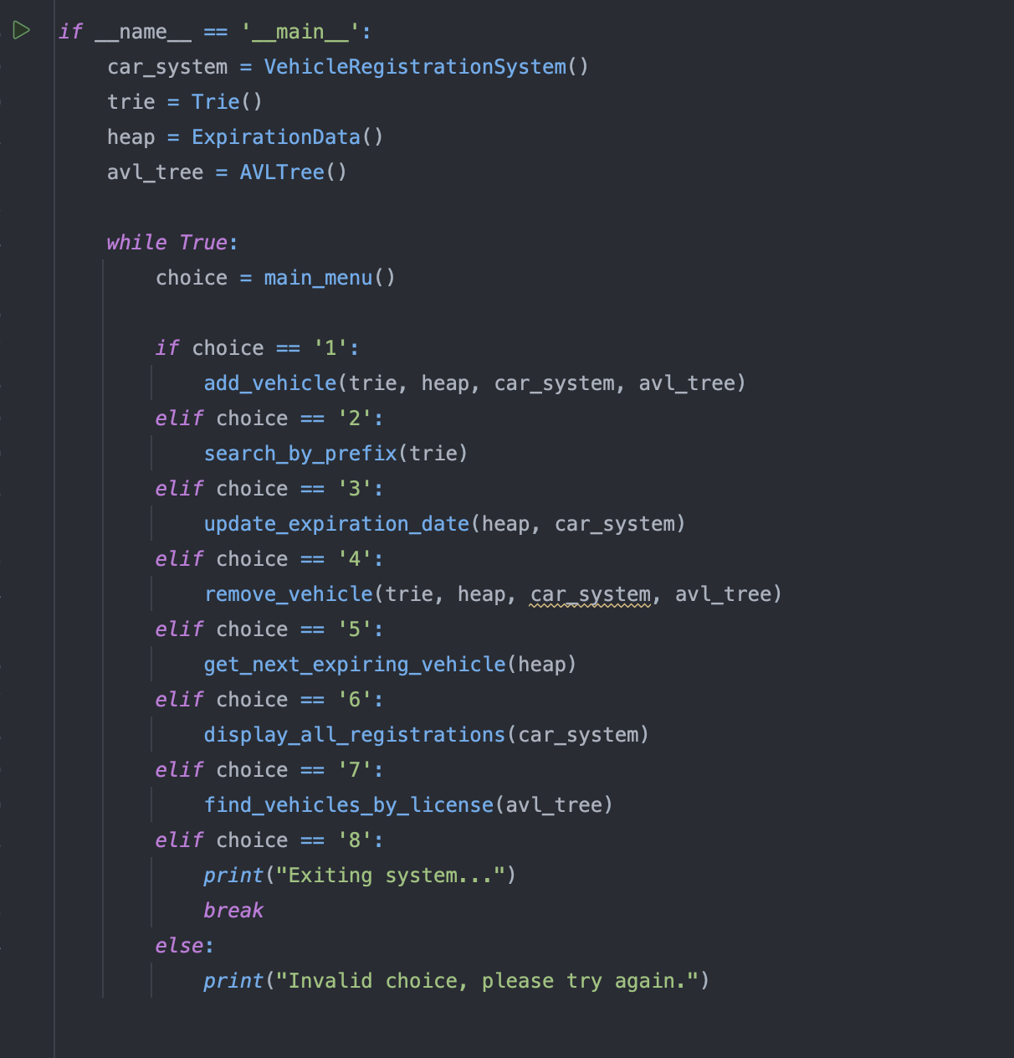

To ensure the user does not enter any wrong format or values here are some steps that I have placed in the add vehicle functions.  
Summary of Validations:

1. First Name & Last Name: Must contain only alphabetic characters.
2. Color: Must contain only alphabetic characters.
3. VIN Number: Must contain only numeric characters.
4. Year: Must be a valid year between 1886 and the current year (numeric).
5. Date Fields (registration_date and expiration_date): Must follow the YYYY-MM-DD format.

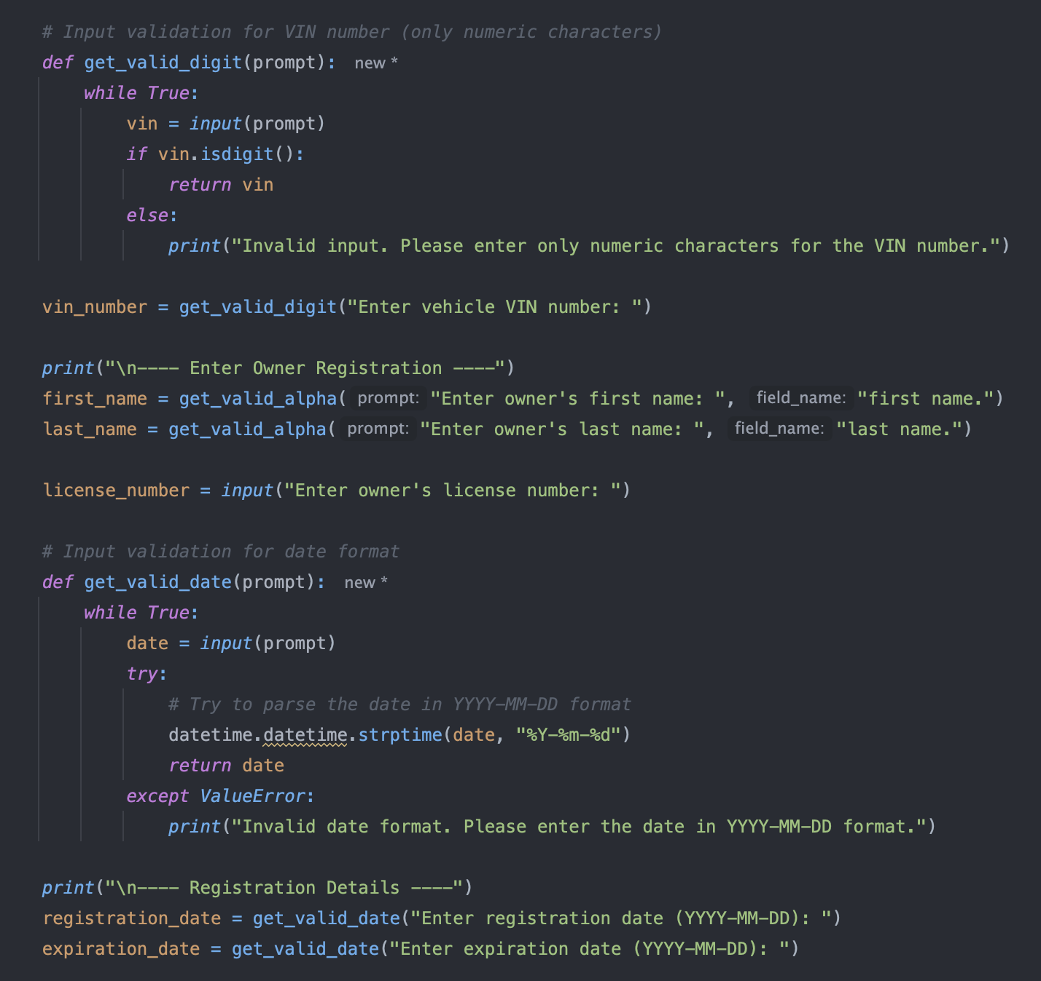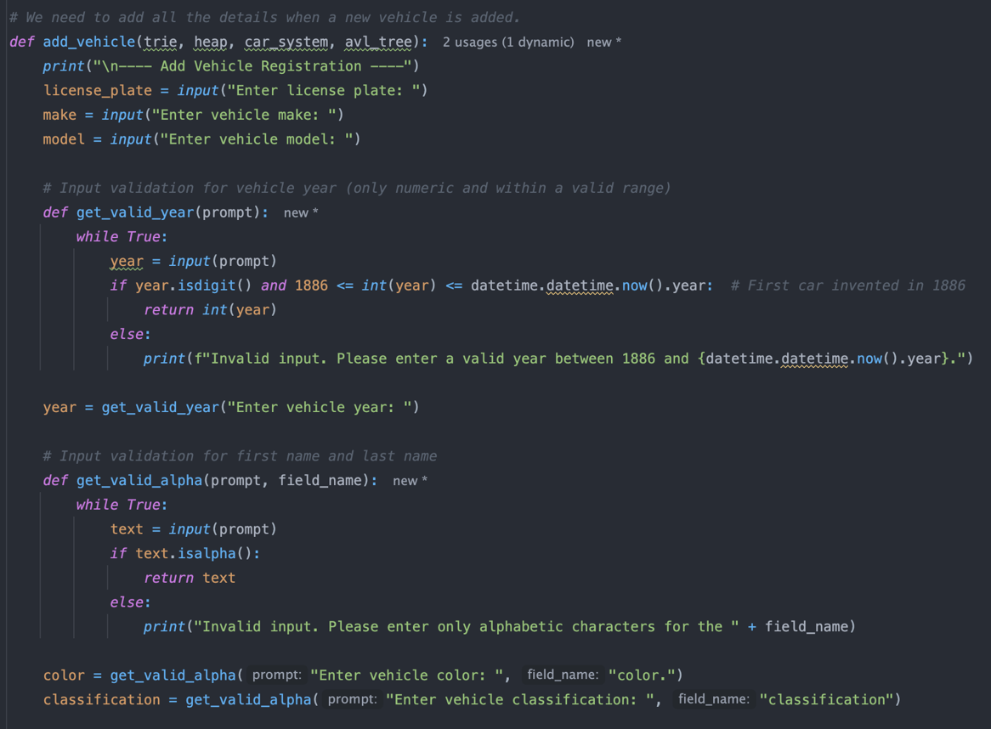

Reference

Goodrich, M. T., & Tamassia, R. (2014). *Data Structures and algorithms in Java Michael T. Goodrich; Roberto Tamassia*. John Wiley.

Knuth, D. E. (1998). *The art of computer programming. volume 3*. Addison-Wesley.

Weiss, M. A. (2012). *Data structures and algorithm analysis in Java*. Addison-Wesley.